Static Design for Machine to Machine Wireless Communication

**MCAL**

**ECUAL**

**Microcontroller**

**APP**

**APP**

LCD

**KeyPad**

EEPROM

**Bluetooth**

**LED**

**DIO**

**PWM**

**TIMER**

I2C

**UART**

MCAL APIs

* DIO APIs

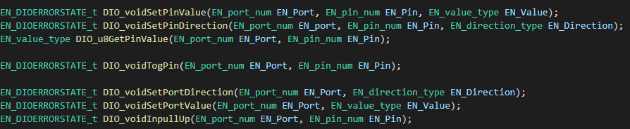

* TIMER APIs

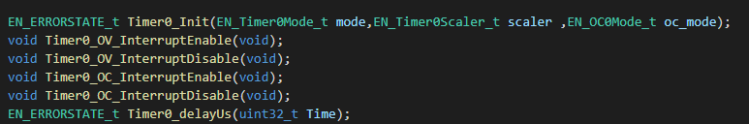

* PWM APIs

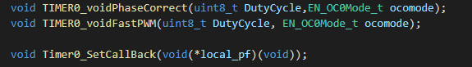

ECUAL APIs

* Buttons APIs



* MOTOR APIs

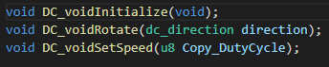

APP APIs

